Oblique Pyramid

Definition
# Source: AI Source: Provided by: [Data Path: Persons Table -> ID Column: 1, Name_En Column: Motasem Essam] -> From: [ChatGPT] on [7/25/2026]
An oblique pyramid is a three-dimensional geometric solid in which the apex is not directly above the center of the base. The perpendicular height from the apex meets the base plane at a point offset from the base center.
Unlike a right pyramid, an oblique pyramid generally has lateral edges of different lengths and triangular lateral faces that differ in shape or size.
An oblique pyramid can have any polygonal base, including a triangle, quadrilateral, pentagon, hexagon, or an $n$-sided polygon.
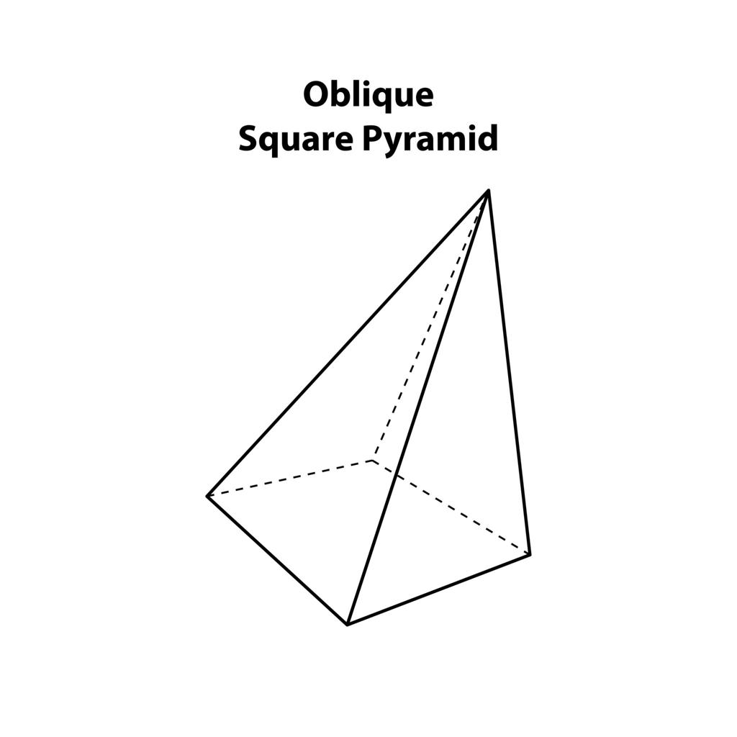
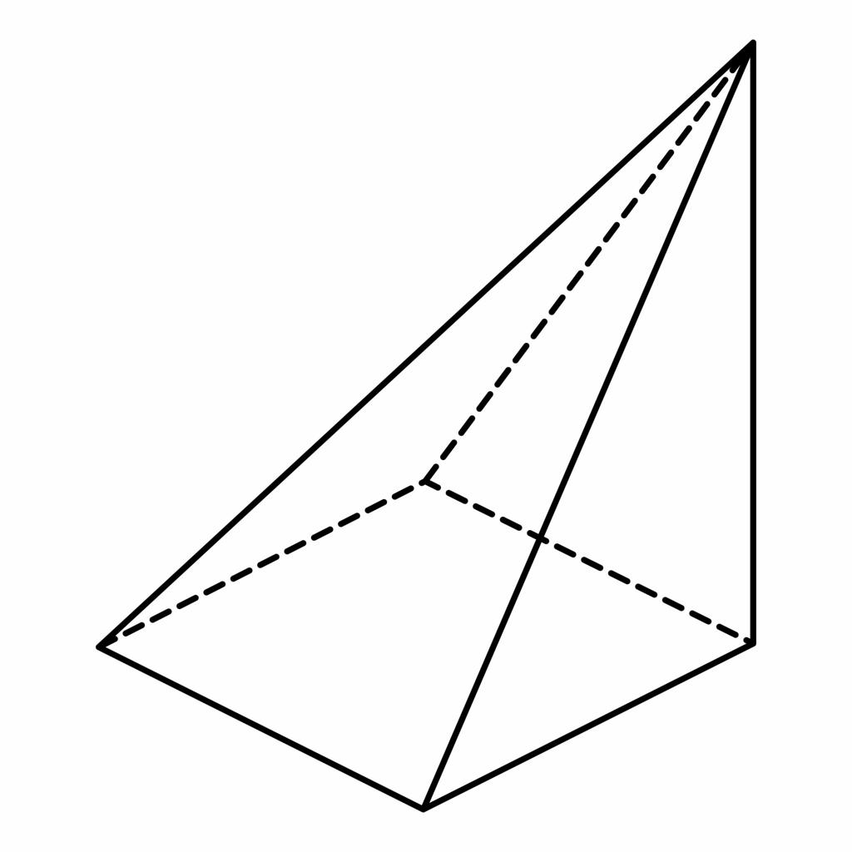
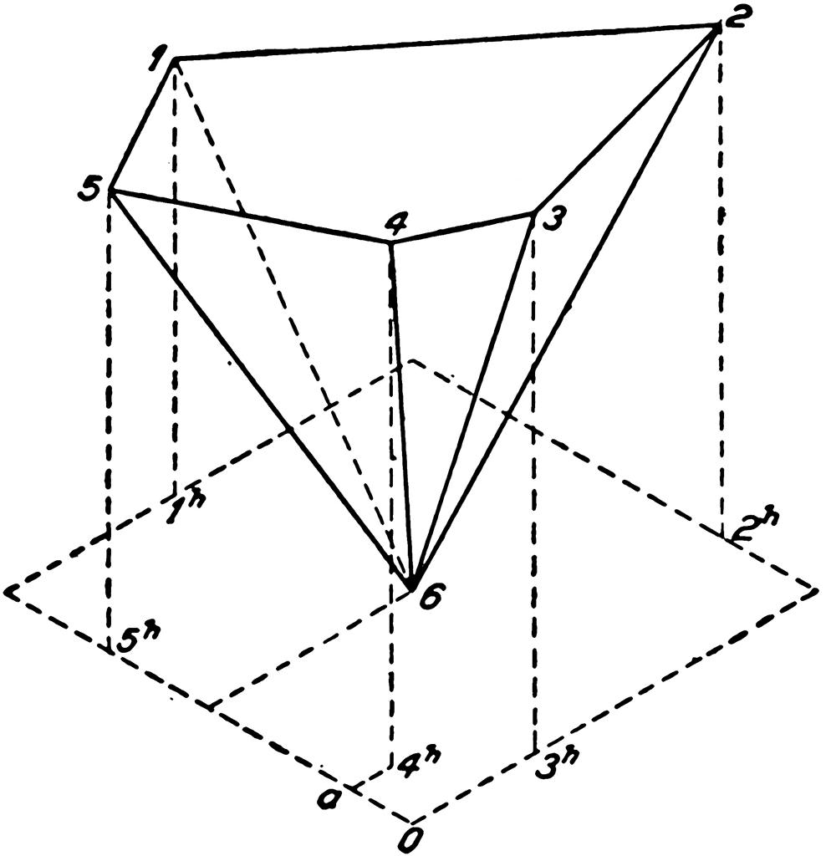

Simple Definition
# Source: AI Source: Provided by: [Data Path: Persons Table -> ID Column: 1, Name_En Column: Motasem Essam] -> From: [ChatGPT] on [7/25/2026]
An oblique pyramid is a pyramid whose apex is shifted to one side rather than positioned directly above the center of its base.
Its height is still measured perpendicular to the base plane, not along a sloping lateral edge.

Classification Tree
# Source: AI Source: Provided by: [Data Path: Persons Table -> ID Column: 1, Name_En Column: Motasem Essam] -> From: [ChatGPT] on [7/25/2026]
Pyramids by Spatial Orientation
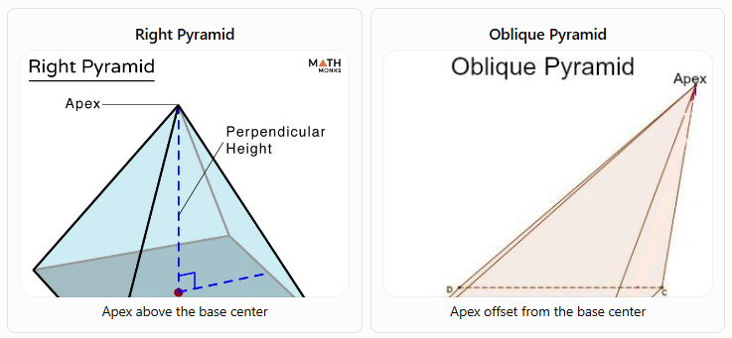
Right Pyramid
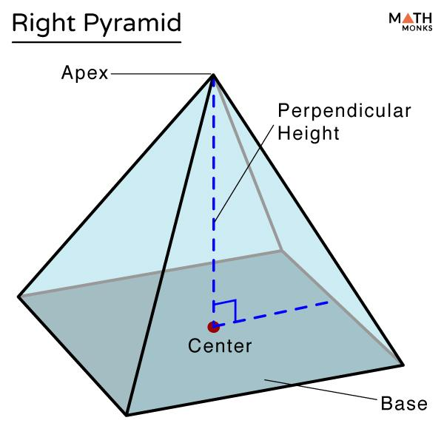
Apex above the base center
Oblique Pyramid
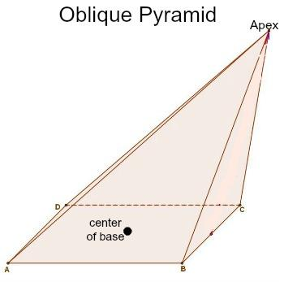
Apex offset from the base center
A. By Base Shape
Oblique pyramids can be classified by the polygon forming their base:
- Oblique triangular pyramid: Has a triangular base and three triangular lateral faces.
- Oblique quadrilateral pyramid: Has a four-sided polygonal base and four triangular lateral faces.
- Oblique pentagonal pyramid: Has a pentagonal base and five triangular lateral faces.
- Oblique hexagonal pyramid: Has a hexagonal base and six triangular lateral faces.
- Oblique \(n\)-gonal pyramid: Has an \(n\)-sided polygonal base and \(n\) triangular lateral faces.
B. By Base Regularity
- Oblique pyramid with a regular base: The base is a regular polygon, but the apex is offset from the base center. The lateral faces are generally not congruent.
- Oblique pyramid with an irregular base: The base is an irregular polygon, and the apex is offset from the chosen base reference center. The lateral faces may differ in both shape and size.

Key Characteristics
# Source: AI Source: Provided by: [Data Path: Persons Table -> ID Column: 1, Name_En Column: Motasem Essam] -> From: [ChatGPT] on [7/25/2026]
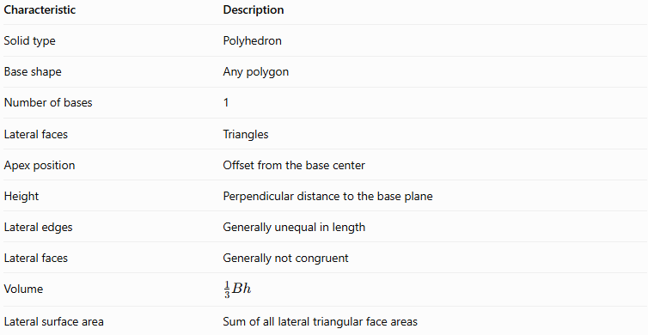
Characteristic | Description
Solid type | Polyhedron
Base shape | Any polygon
Number of bases | 1
Lateral faces | Triangles
Apex position | Offset from the base center
Height | Perpendicular distance to the base plane
Lateral edges | Generally unequal in length
Lateral faces | Generally not congruent
Volume | $$\frac{1}{3}Bh$$
Lateral surface area | Sum of all lateral triangular face areas
For an oblique pyramid with an \(n$n$ded base:
\[
$$F=n+1, E=2n, V_{e}=n+1$$s face, edge, and vertex counts are the same as those of a right pyramid with the same number of base sides.

Geometric Representation
# Source: AI Source: Provided by: [Data Path: Persons Table -> ID Column: 1, Name_En Column: Motasem Essam] -> From: [ChatGPT] on [7/25/2026]
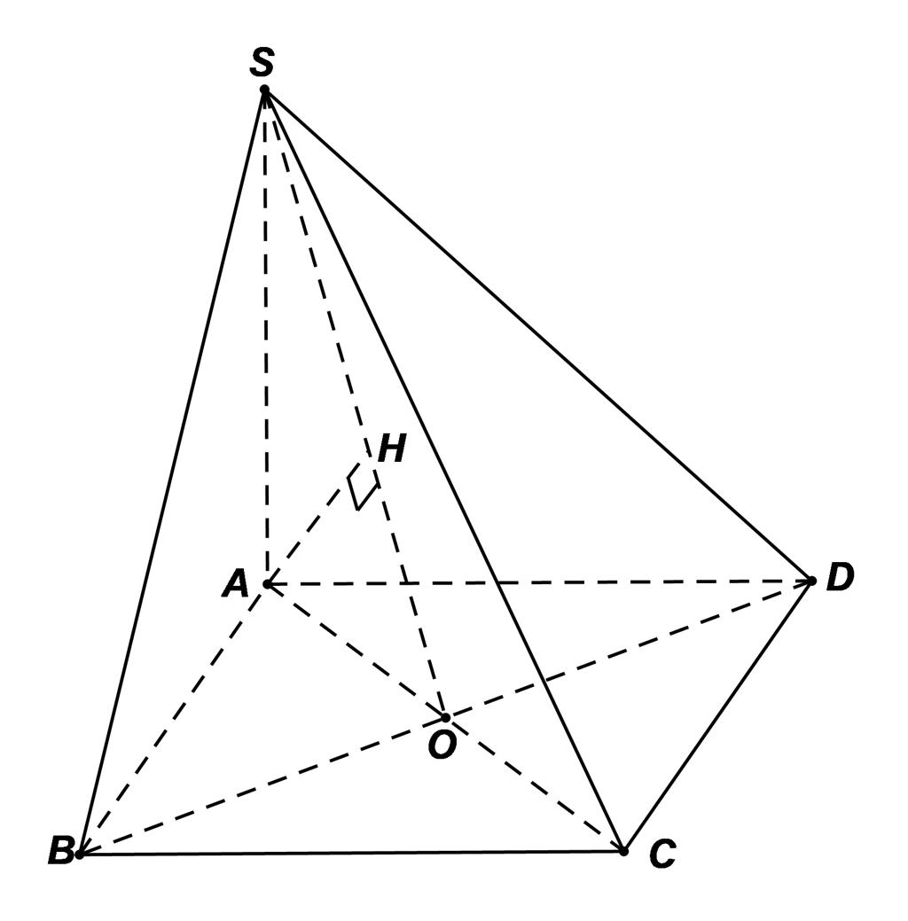
Consider an oblique square pyramid with apex $S$, square base $ABCD$, and perpendicular height $SO$.
Its components are:
- Base $ABCD$: The polygon forming the bottom face.
- Apex $S$: The vertex positioned off-center relative to the base.
- Height $SO$: The perpendicular distance from the apex to the plane containing the base.
- Base edges: $AB,BC,CD,$ and $DA$.
- Lateral edges: $SA,SB,SC,$ and $SD$.
- Lateral faces: Triangles $SAB,SBC,SCD,$ and $SDA$.
- Slant heights: The perpendicular distances from the apex to individual base edges, measured along their corresponding triangular faces when the perpendicular foot lies on those faces. These distances generally differ.
Important distinction: The perpendicular height does not have to follow any lateral edge. Even in an oblique pyramid, the volume depends on the perpendicular height, not on the length of a sloping edge.

6. Mathematical Representations and Formulas
# Source: AI Source: Provided by: [Data Path: Persons Table -> ID Column: 1, Name_En Column: Motasem Essam] -> From: [ChatGPT] on [7/25/2026]
Let:
- $B$ = base area
- $p$ = base perimeter
- $h$ = perpendicular height
- $A_{i}$ = area of the $i$-th lateral triangular face
- $n$ = number of sides of the base

A. Volume
# Source: AI Source: Provided by: [Data Path: Persons Table -> ID Column: 1, Name_En Column: Motasem Essam] -> From: [ChatGPT] on [7/25/2026]
The volume formula is the same for right and oblique pyramids:
$$\boxed{V=\frac{1}{3}Bh}$$
The position of the apex does not change the formula, provided $h$ is measured perpendicular to the base plane.

B. Lateral surface area
# Source: AI Source: Provided by: [Data Path: Persons Table -> ID Column: 1, Name_En Column: Motasem Essam] -> From: [ChatGPT] on [7/25/2026]
For an oblique pyramid, calculate the area of each triangular lateral face and add them:
$$\boxed{A_{L}=\sum_{i=1}^{n}{A_{i}}}$$
For each triangular face:
$$A_{i}=\frac{1}{2}b_{i}s_{i}$$
where $b_{i}$ is the corresponding base edge and $s_{i}$ is the perpendicular altitude within that triangular face.
Therefore:
$$\boxed{A_{L}=\frac{1}{2}\sum_{i=1}^{n}{b_{i}}s_{i}}$$
Unlike a regular right pyramid, an oblique pyramid generally does not have one common face slant height that can be used in $A_{L}=\frac{1}{2}pl$.

C. Total surface area
# Source: AI Source: Provided by: [Data Path: Persons Table -> ID Column: 1, Name_En Column: Motasem Essam] -> From: [ChatGPT] on [7/25/2026]
The total surface area is the sum of the base area and the lateral surface area:
$$\boxed{A_{T}=B+A_{L}}$$

D. Number of faces, edges, and vertices
# Source: AI Source: Provided by: [Data Path: Persons Table -> ID Column: 1, Name_En Column: Motasem Essam] -> From: [ChatGPT] on [7/25/2026]
For an oblique pyramid with an $n$-sided base:
$$\boxed{F=n+1}$$
$$\boxed{E=2n}$$
$$\boxed{V_{e}=n+1}$$

E. Euler's formula
# Source: AI Source: Provided by: [Data Path: Persons Table -> ID Column: 1, Name_En Column: Motasem Essam] -> From: [ChatGPT] on [7/25/2026]
For a convex oblique pyramid:
$$\boxed{V_{e}-E+F=2}$$
Substituting the general counts:
$$\left(n+1\right)-2n+\left(n+1\right)=2$$
Thus, an oblique pyramid satisfies Euler's formula just as a right pyramid does.

Worked Examples
# Source: AI Source: Provided by: [Data Path: Persons Table -> ID Column: 1, Name_En Column: Motasem Essam] -> From: [ChatGPT] on [7/25/2026]
Example 1: Calculating volume
Problem: An oblique pyramid has a base area of $80{\text{ cm}}^{2}$ and a perpendicular height of $12\text{ cm}$. Find its volume.
Solution:
$$V=\frac{1}{3}Bh$$
$$V=\frac{1}{3}\left(80\right)\left(12\right)$$
$$\boxed{V=320{\text{ cm}}^{3}}$$
Example 2: Calculating lateral surface area
Problem: An oblique pyramid has four triangular lateral faces with areas of $15$, $18$, $20$, and $17{\text{ cm}}^{2}$. Find its lateral surface area.
Solution:
$$A_{L}=15+18+20+17$$
$$\boxed{A_{L}=70{\text{ cm}}^{2}}$$
Each triangular face is calculated separately because the faces may have different dimensions.
Example 3: Calculating total surface area
Problem: An oblique pyramid has a base area of $36{\text{ cm}}^{2}$ and a lateral surface area of $70{\text{ cm}}^{2}$. Find its total surface area.
Solution:
$$A_{T}=B+A_{L}$$
$$A_{T}=36+70$$
$$\boxed{A_{T}=106{\text{ cm}}^{2}}$$
Example 4: Counting geometric elements
Problem: Find the faces, edges, and vertices of an oblique octagonal pyramid.
An octagon has $n=8$ sides.
$$F=n+1=9$$
$$E=2n=16$$
$$V_{e}=n+1=9$$
Answer: 9 faces, 16 edges, and 9 vertices.
Example 5: Verifying Euler's formula
Using the octagonal pyramid from Example 4:
$$V_{e}-E+F=9-16+9=2$$
Therefore, the oblique octagonal pyramid satisfies Euler's formula.

Comparison with Related Types of Pyramids
# Source: AI Source: Provided by: [Data Path: Persons Table -> ID Column: 1, Name_En Column: Motasem Essam] -> From: [ChatGPT] on [7/25/2026]
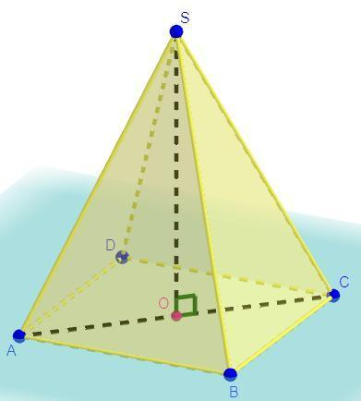
Right Pyramid
- Apex is above the base center.
- Height meets the base at its center.
- A regular right pyramid has congruent lateral faces.
- Regular-pyramid lateral area: $\frac{1}{2}pl$.
Oblique Pyramid
- Apex is offset from the base center.
- Lateral edges and faces are generally unequal.
- Lateral area is calculated by adding individual face areas.
- Volume: $\frac{1}{3}Bh$.
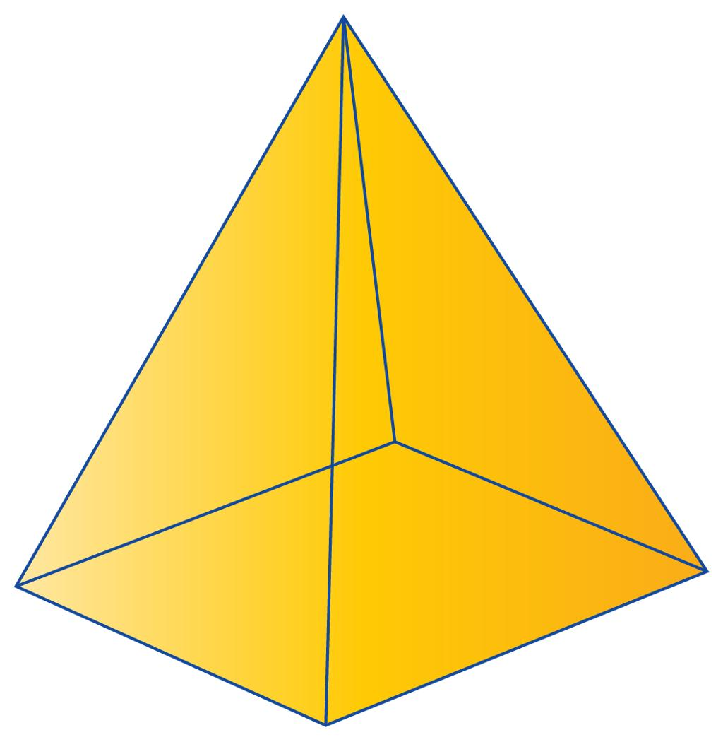
Regular Pyramid
- Has a regular polygonal base.
- Apex lies above the base center.
- Lateral faces are congruent isosceles triangles.
- It is a special type of right pyramid.

Applications
# Source: AI Source: Provided by: [Data Path: Persons Table -> ID Column: 1, Name_En Column: Motasem Essam] -> From: [ChatGPT] on [7/25/2026]
Oblique pyramids are useful in:
- Architecture: Designing asymmetrical roofs, decorative structures, and unconventional building forms.
- Engineering: Modeling tapered components whose apex is not centered over the base.
- Computer graphics: Creating asymmetrical 3D objects and polygon meshes.
- Mathematics education: Comparing perpendicular height with sloping edges and face altitudes.
- Geometric modeling: Demonstrating how moving the apex changes a solid's shape without changing the general pyramid volume formula.

Key Points
# Source: AI Source: Provided by: [Data Path: Persons Table -> ID Column: 1, Name_En Column: Motasem Essam] -> From: [ChatGPT] on [7/25/2026]
- An oblique pyramid has an apex offset from the base center.
- Its height is measured perpendicular to the base plane.
- It has one polygonal base and triangular lateral faces.
- For an $n$-gonal oblique pyramid, the number of faces is $n+1$, the number of edges is $2n$, and the number of vertices is $n+1$.
- Its volume is $V=\frac{1}{3}Bh$, just like a right pyramid.
- Its lateral surface area is generally calculated by adding the areas of its individual triangular faces.
- A regular polygonal base does not make a pyramid a regular pyramid if the apex is offset from the base center.

Conclusion
# Source: AI Source: Provided by: [Data Path: Persons Table -> ID Column: 1, Name_En Column: Motasem Essam] -> From: [ChatGPT] on [7/25/2026]
An oblique pyramid is a polyhedron whose apex is displaced from the center of its base. This position generally creates unequal lateral edges and lateral faces, making its surface-area calculations different from those of a regular right pyramid. However, its volume formula and its general relationships among faces, edges, and vertices remain unchanged. Understanding oblique pyramids helps distinguish how a solid's orientation affects its geometry without changing its fundamental classification as a pyramid.

